**Problem 1,Part 1**

For 1th Iteration B :

[[ 1 -3]

[ 3 2]]

For 1th Iteration N :

[[-1 4 4]

[ 2 1 -1]]

For 1th Iteration r :

[-5. -7. -8.]

For 2th Iteration B :

[[ 1 -1]

[ 3 2]]

For 2th Iteration N :

[[-3 4 4]

[ 2 1 -1]]

For 2th Iteration r :

[-2.09090909 1. 3.63636364]

For 3th Iteration B :

[[ 4 -1]

[ 1 2]]

For 3th Iteration N :

[[-3 1 4]

[ 2 3 -1]]

For 3th Iteration r :

[ 4.6 -3.6 -1.8]

Value of X :

[[0. ]

[0. ]

[1.66666667]

[0.66666667]

[0. ]]

Cost :

-2.0

## Problem 1,Part 2

For 1th Iteration B :

[[2 3]

[3 1]]

For 1th Iteration N :

[[-2 1 2]

[ 0 2 -2]]

For 1th Iteration r :

[ 3. 5. -1.]

For 2th Iteration B :

[[ 2 2]

[ 3 -2]]

For 2th Iteration N :

[[-2 1 3]

[ 0 2 1]]

For 2th Iteration r :

[ 3.28571429 5.71428571 -1.14285714]

Value of X :

[[0.8]

[0. ]

[0. ]

[0. ]

[1.2]]

Cost :

0.8000000000000003

## Problem 2

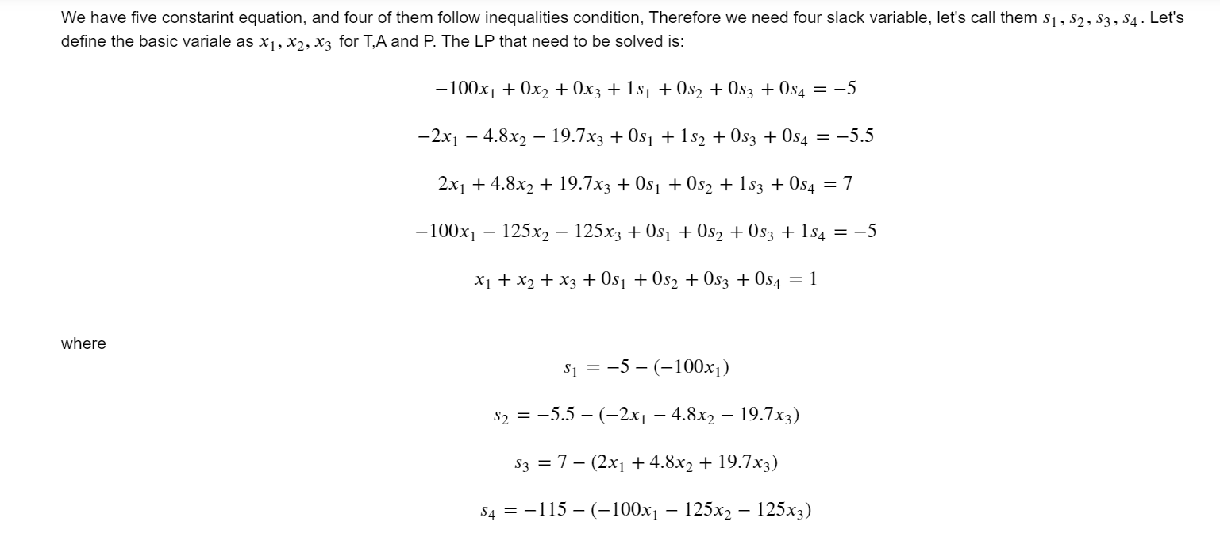

Result for Iteration(Using 0,1,2,3,4 columns as an initial guess):

For 1th Iteration B :

[[-100. 0. 0. 0. 0. ]

[ -2. -4.8 -19.7 0. 1. ]

[ 2. 4.8 19.7 0. 0. ]

[-100. -125. -125. 1. 0. ]

[ 1. 1. 1. 0. 0. ]]

For 1th Iteration N :

[[0. 1.]

[0. 0.]

[1. 0.]

[0. 0.]

[0. 0.]]

For 1th Iteration r :

[-4.50401138e-16 -6.00000000e-01]

For 2th Iteration B :

[[-100. 0. 0. 0. 0. ]

[ -2. -4.8 -19.7 0. 0. ]

[ 2. 4.8 19.7 0. 1. ]

[-100. -125. -125. 1. 0. ]

[ 1. 1. 1. 0. 0. ]]

For 2th Iteration N :

[[0. 1.]

[1. 0.]

[0. 0.]

[0. 0.]

[0. 0.]]

For 2th Iteration r :

[-5.08541755e-17 1.50000000e-01]

Value of X :

[[0.05 ]

[0.89362416]

[0.05637584]

[0. ]

[0. ]

[1.5 ]

[8.75 ]]

Cost :

30.75

0.05 + 0.89 + 0.056 = 1, i.e T + A + P = 1